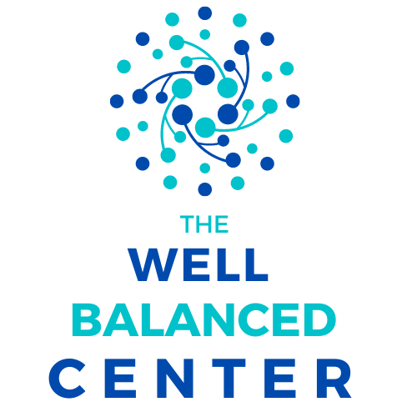
Establishing Your Personal Mission Statement

Your mission statement outlines your life purpose, emphasizing what is truly important to you. It combines your values, expectations, and your measurement of success. Getting clear about what you want out of life and discovering why your goals are important to you helps you remain centered for your habits, routines, decisions, and future goals.

Here are the prep steps:
- Think of someone that inspires you, describe the qualities they have:

- How would you want someone to describe you?

- What would you like your legacy to be?

- What are your physical, mental, emotional, and spiritual purposes?

- What are your abilities/talents/skills?

- What are your specific life goals?

I am at my best when: _____________________________________________________________
I will prevent times when:___________________________________________________________
I feel in the zone when:_____________________________________________________________
I enjoy doing this most days:_________________________________________________________
I will find opportunities to:____________________________________________________________
My life’s journey is unique because:____________________________________________________
I want to be seen as a person that can:_________________________________________________
My future contribution to society is:_____________________________________________________
I will start working on:_______________________________________________________________
I will strive to be more:_______________________________________________________________
I will renew myself by focusing on these four:_____________________________________________

My mission is to create a life where
I use these skills:
And seek to:
To help influence
In order to build:
And provide more opportunities to:

Adapted from: https://www.developgoodhabits.com/personal-mission-statement/

